|  |  |  |  |  |  |
| --- | --- | --- | --- | --- | --- |
| Submit your team’s timesheets in mass  **Step 1**: Click on the **Team Time** worklet on your home screen  and click on **Review Time** under **Actions.**  cid:image002.png@01D25A34.D7430AA0   |  |  | | --- | --- | |  | Note: Timekeepers will have a **Team Time** worklet but it won’t display groups of workers as the **Team Time** worklet does for managers. | | **Step 2:**  Enter the date and who you want to see. Then click **OK**.     |  |  | | --- | --- | |  | Note: Workday limits 50 employees in review time at once. An error will occur if you have more than 50 employees at a time. | |

**Step 3:** From this report (worklet) you can easily identify what hours have not been submitted, add/edit time, and mass approve timesheets. **Note:** A job is set up to run nightly to submit all time, however it will not submit time for anyone that has an unmatched punch or is still clocked in. This way you will only have to approve, not submit the time.

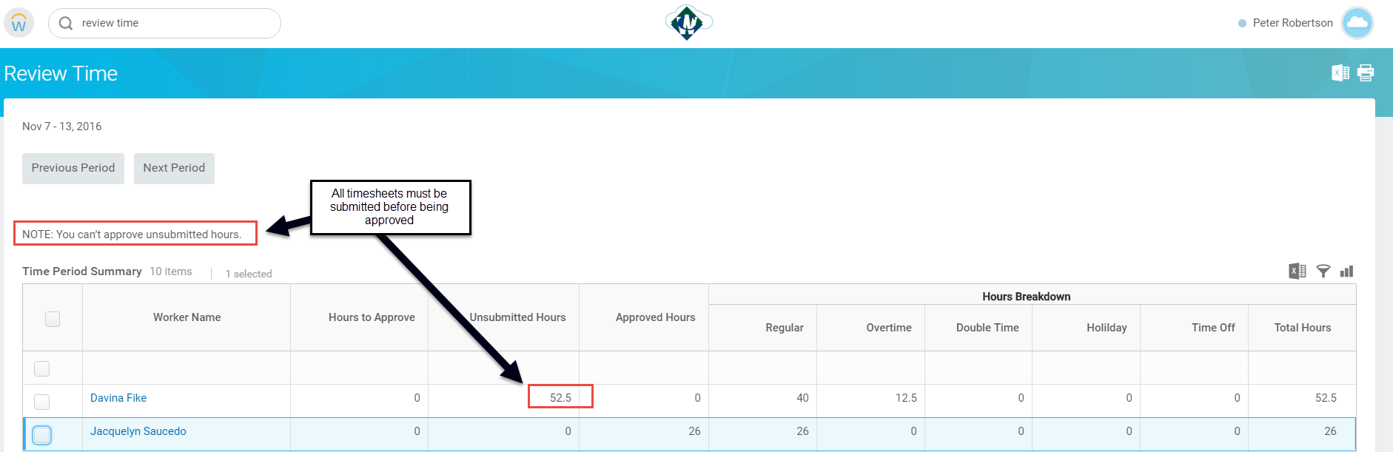

|  |  |
| --- | --- |
|  | Note: When time is submitted by a manager, it is also automatically approved. |

Modify your team’s timesheets

**Step 1:** To review or make changes you can “Drill In” to each person’s specific timesheet by clicking on the person's name (anytime words are blue you can click on it to get an explanation or drill down on something)

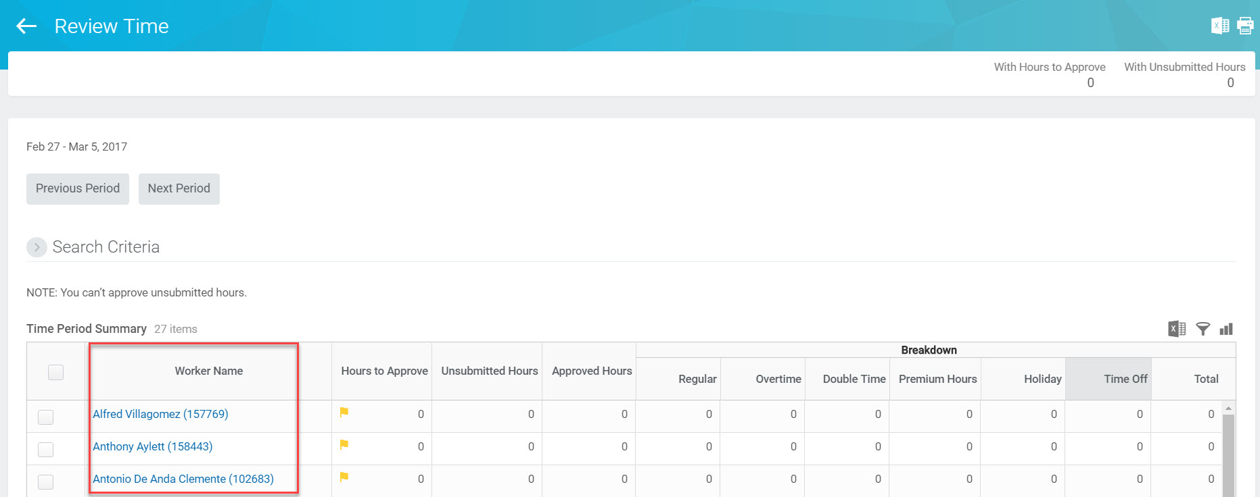

It may be easier to review an employee’s specific timesheet in a new window. Position your cursor to the top of the screen on the open tab and right click. Select **Duplicate** and left click. You will then have two windows open in Workday and one can be used to drill into an individual employee.

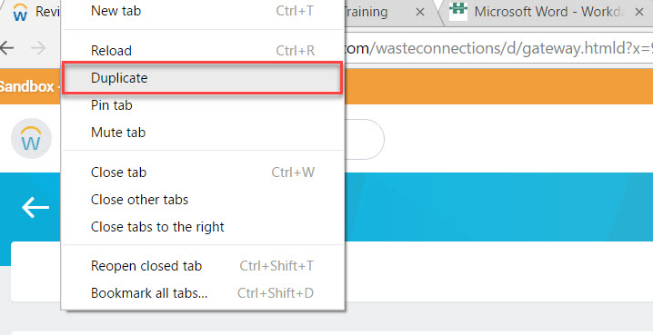

**Step 2:** Once the employee is pulled up, **Daily Totals** are shown. Click on **All Entries** for more detail.

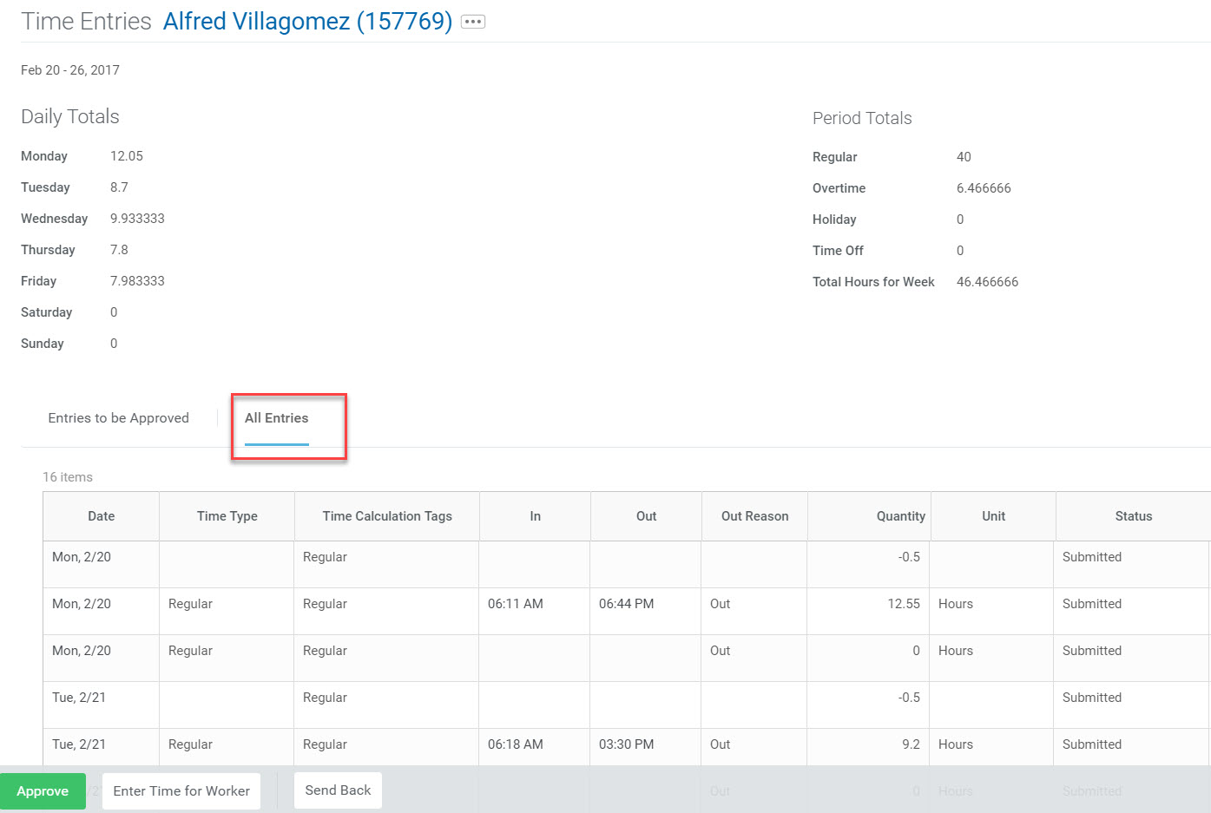

**Step 3:** To edit or enter time click on **Enter Time for Worker** in the bottom left-hand corner.

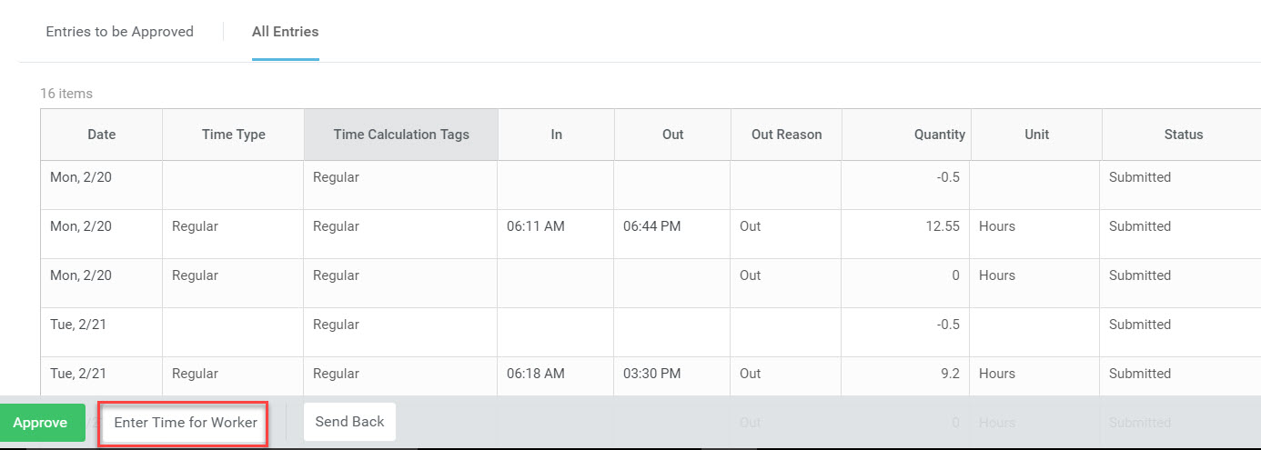

**Step 4:** Enter time for an employee clicking in the time blocks. The field will become blue and the **Enter Time** pop-up screen will appear. Complete all required and applicable fields and click **OK.** The **Enter Time** pop-up screen will then disappear. Click **Submit.**

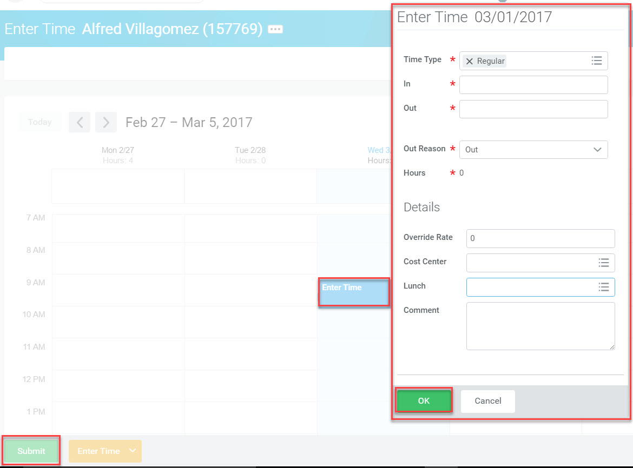

|  |  |
| --- | --- |
|  | Note: Managers and timekeepers may need to periodically enter time for employees. However, if doing so too frequently, check the clock-in capabilities on all devices that should enable employees to do this themselves. |

To edit a time entry, click on the actual time block. The **Enter Time** pop-up box appears. Edit as necessary and click **OK.** Then click **Submit.**

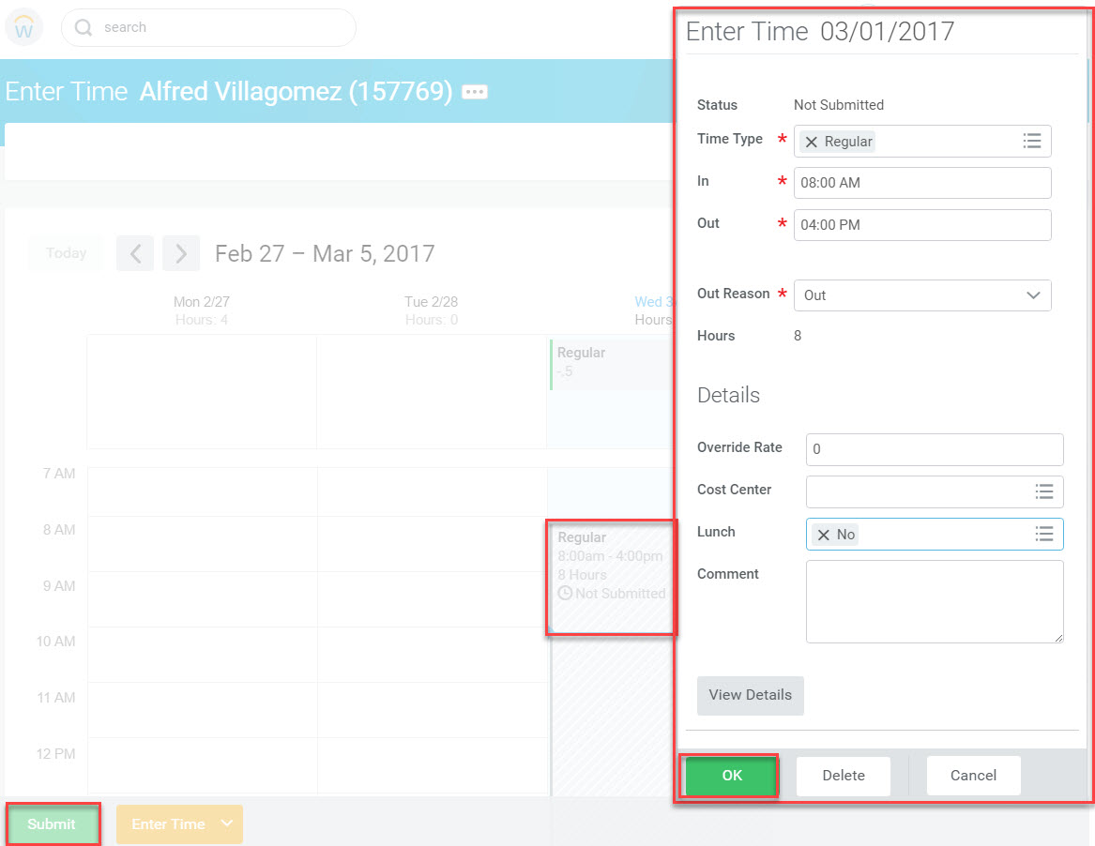

|  |  |
| --- | --- |
|  | Note: Submitted and approved time may be edited until the timesheet is closed. |

**Edit Tips: Time Type**

When entering or editing time, select the appropriate time type by clicking the prompt icon in the **Time Type** field. The various time types can be accessed under **Time Entry Codes** or **Time Off.** Select the appropriate option and click **OK.**

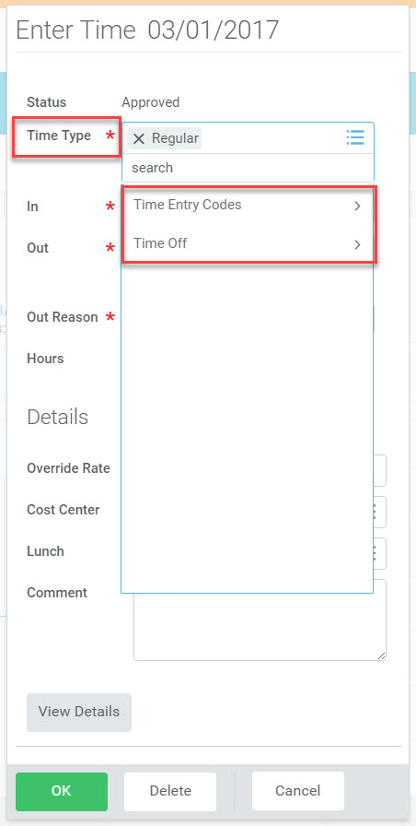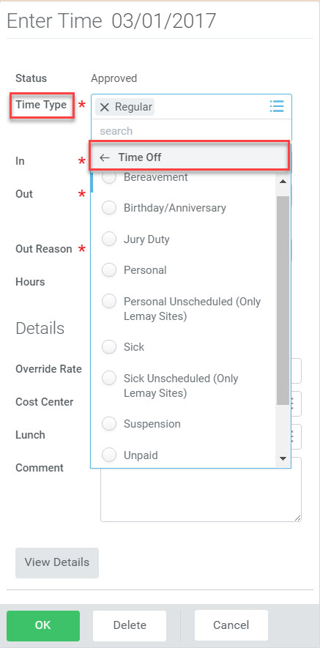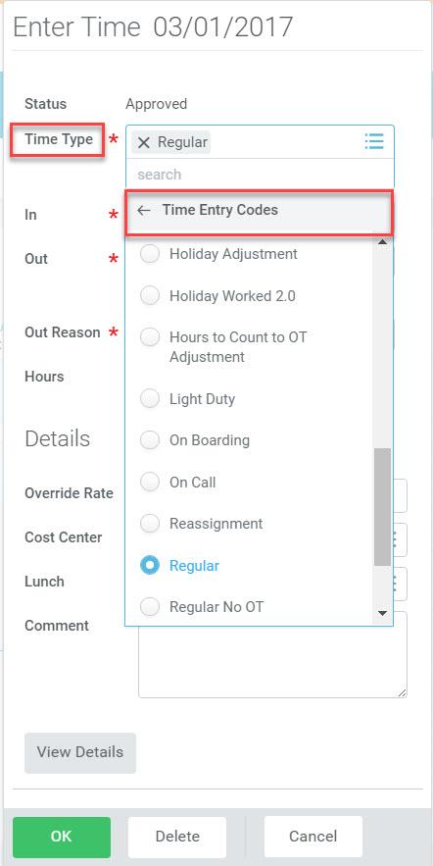

**Edit Tips: Remove Auto Meal**

From the **Enter Time** pop-up screen, click the prompt icon in the **Lunch** field to access the drop-down menu. Select **No** and click **OK.** Once done, you’ll notice that the auto meal indicator will disappear.

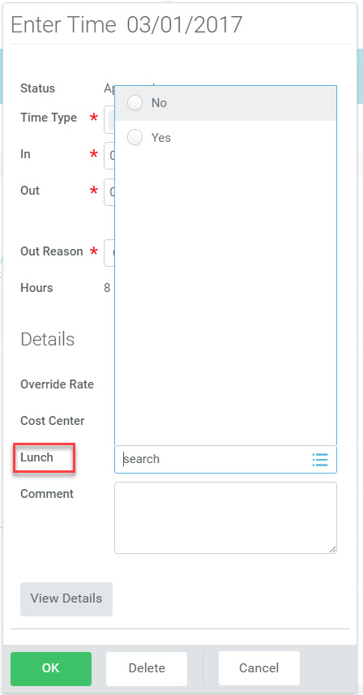

**Edit Tips: Unmatched Punches**

Edits can be made at the punch and correcting time outside of the punch requires you to delete the unmatched punch for audit purposes.

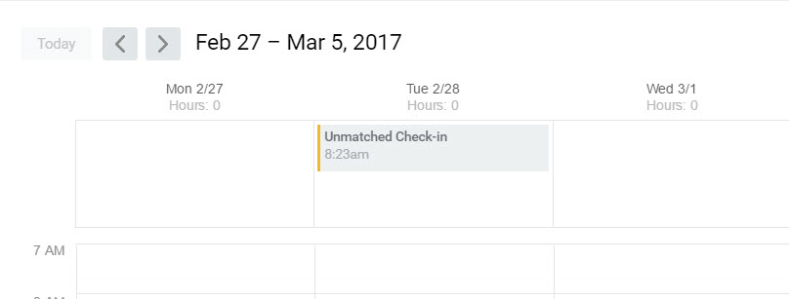

**Edit Tips: Punch Out Reason**

If an employee accidentally chooses “meal” instead of “out”, the next day’s hours are captured in the previous day.

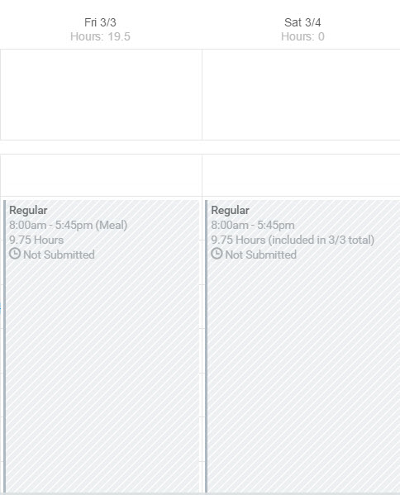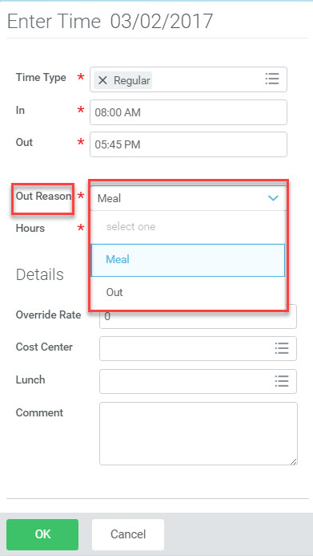

This can be corrected by opening the timebox and editing “meal” to “out”. The hours will then correct itself.

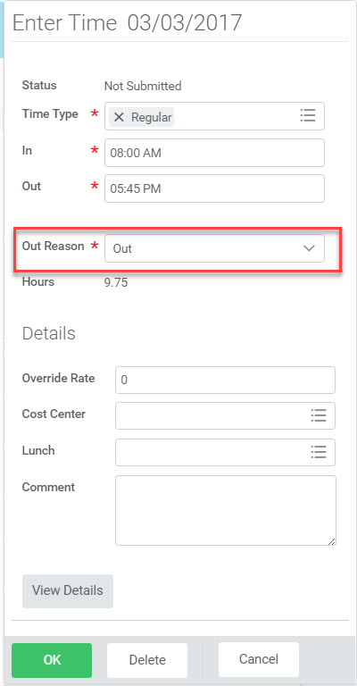

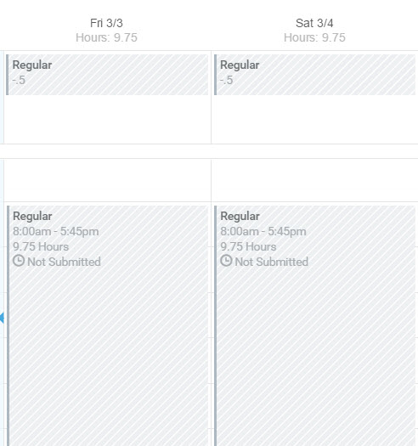

**Edit Tips: View Details**

From the time block, clicking **View Details** will display **Reported, Calculated, and History** details.

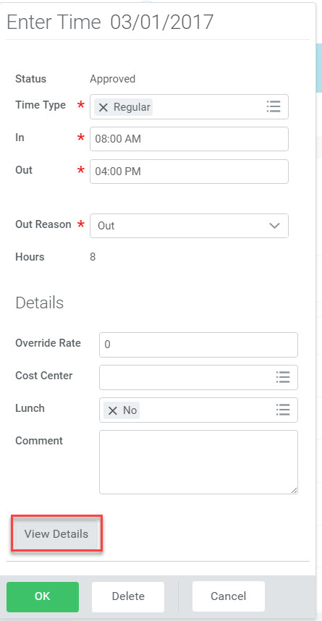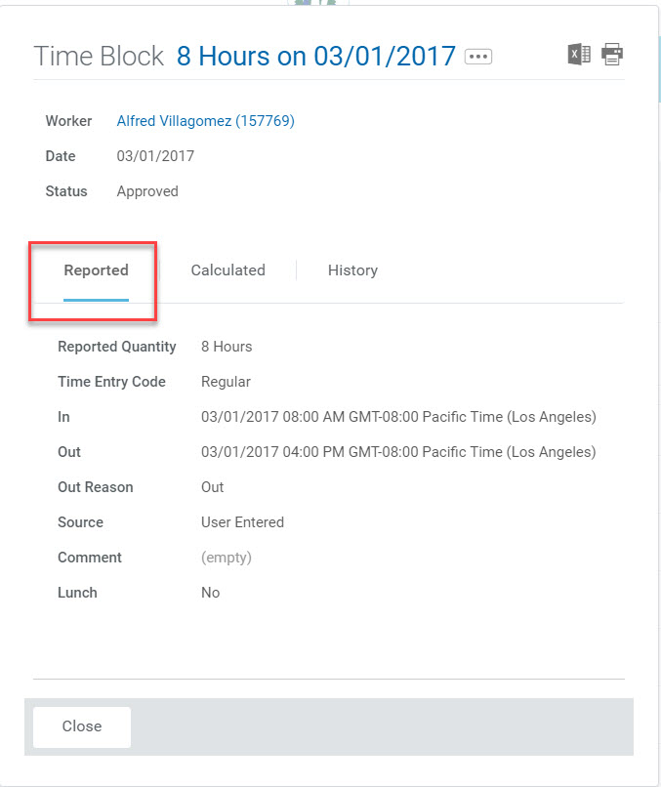

Note that the Calculated tab will provide details regarding what hours are mapped to the specific time calculation. Also, the information displayed in the History tab is contingent upon user-security access.

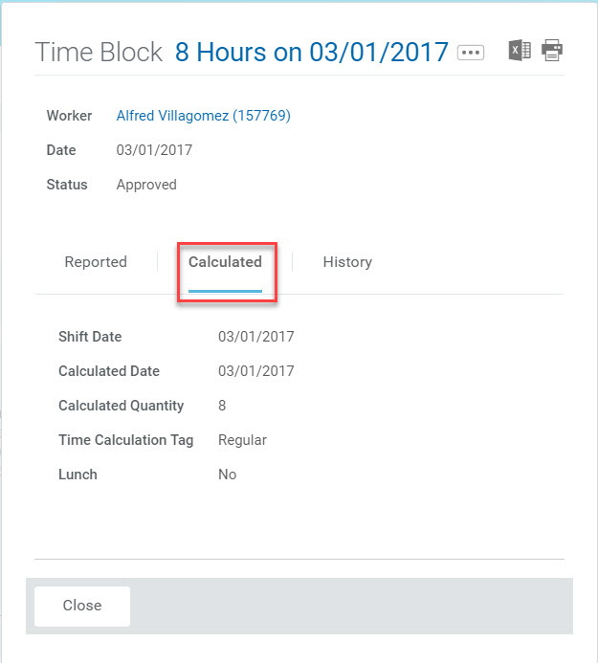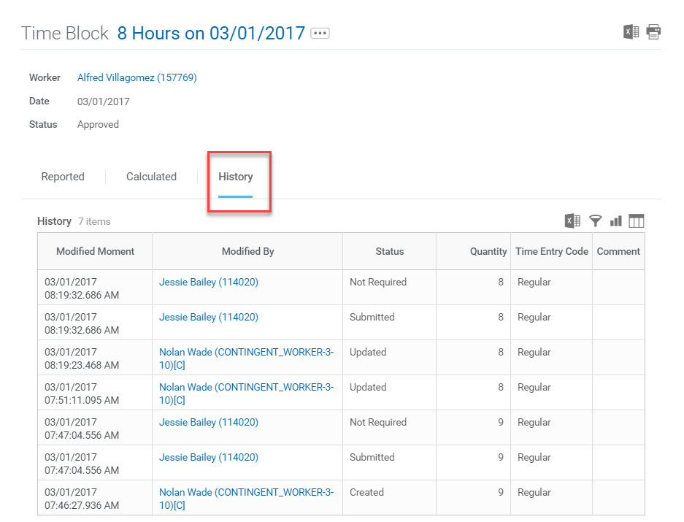

**Edit Tips: Enter Time Off**

From **Actions,** click **Enter Time Off**

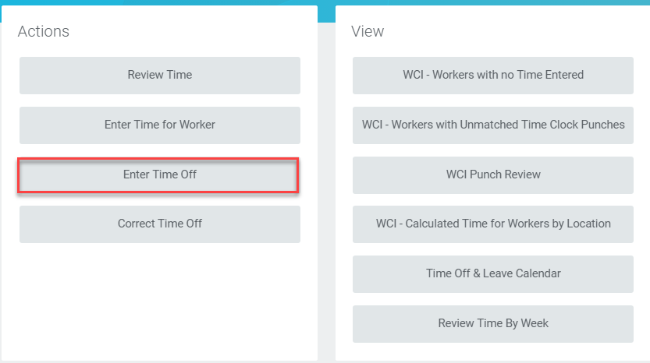

Enter the employee’s name. Click **OK**

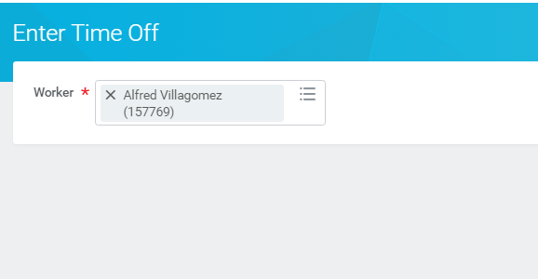

Click and drag to select one day or a range of dates on the calendar. Click the **Request Time Off** button.

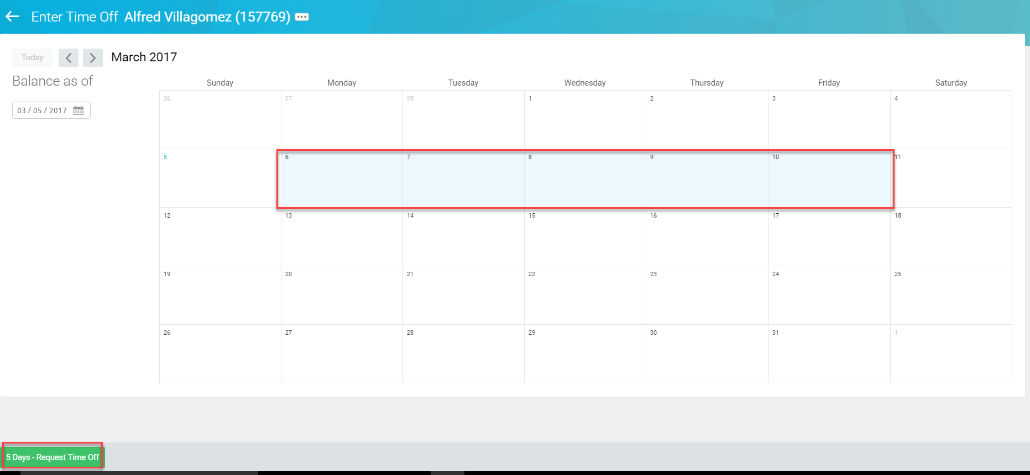

Enter the time off type (ex. vacation, sick, personal, etc.), then enter the daily quantity (the number of hours per day), and the total hours requested for all days will then display in the top right corner. Click **Submit.** If entered by a manager, the time will automatically be approved.

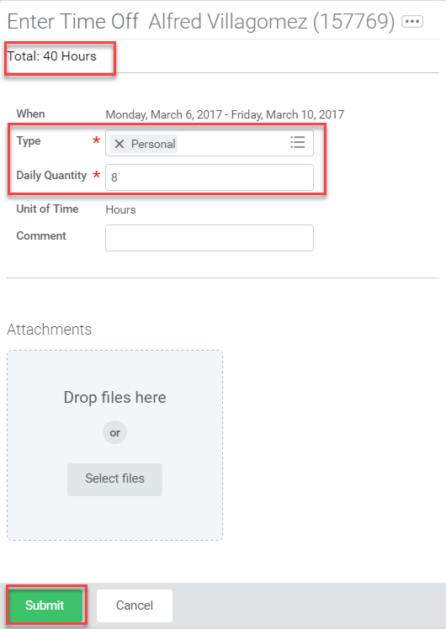

|  |  |
| --- | --- |
|  | Note: Approving time off in a timely manner is very critical. Any time off not approved before payroll is complete will not be paid to employees. If you approve it after payroll is complete, it will go on the next available check. When payroll runs the mass submit/approve process, it only picks up time not time off. There is no way for Payroll to approve time off, only the mangers. |

**Edit Tips: Correct Time Off**

From Actions, click **Correct Time Off**

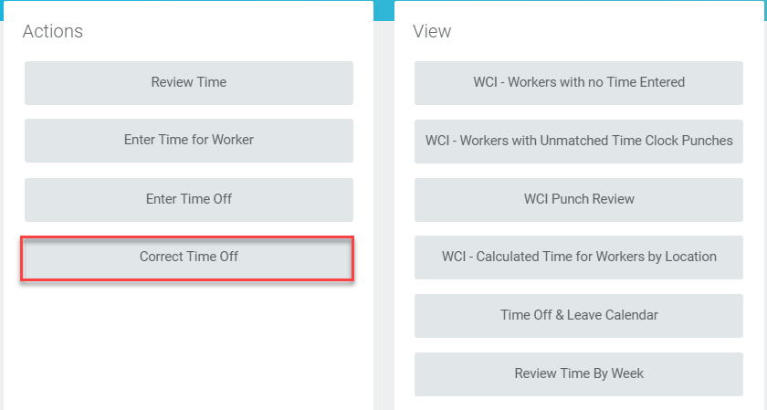

Enter the employee’s name. Click **OK**

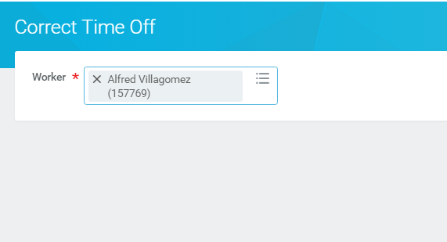

Click on the time-off entry to be corrected.

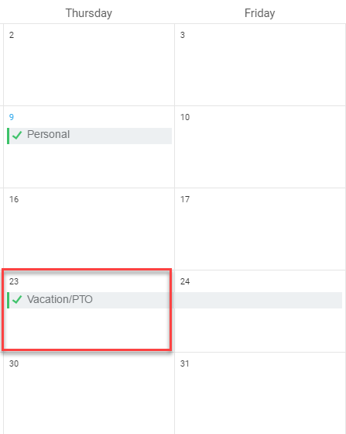

The Correct Time Off screen displays. To remove the time off originally requested, click the **Remove Row**  button in the left margin next to the date to be corrected. Once done, click **Continue.**

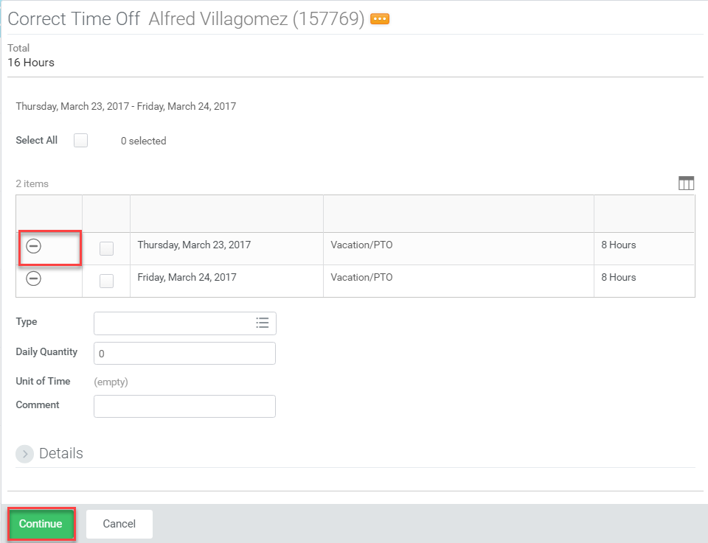

Click **Submit** from the Correct Time Off view

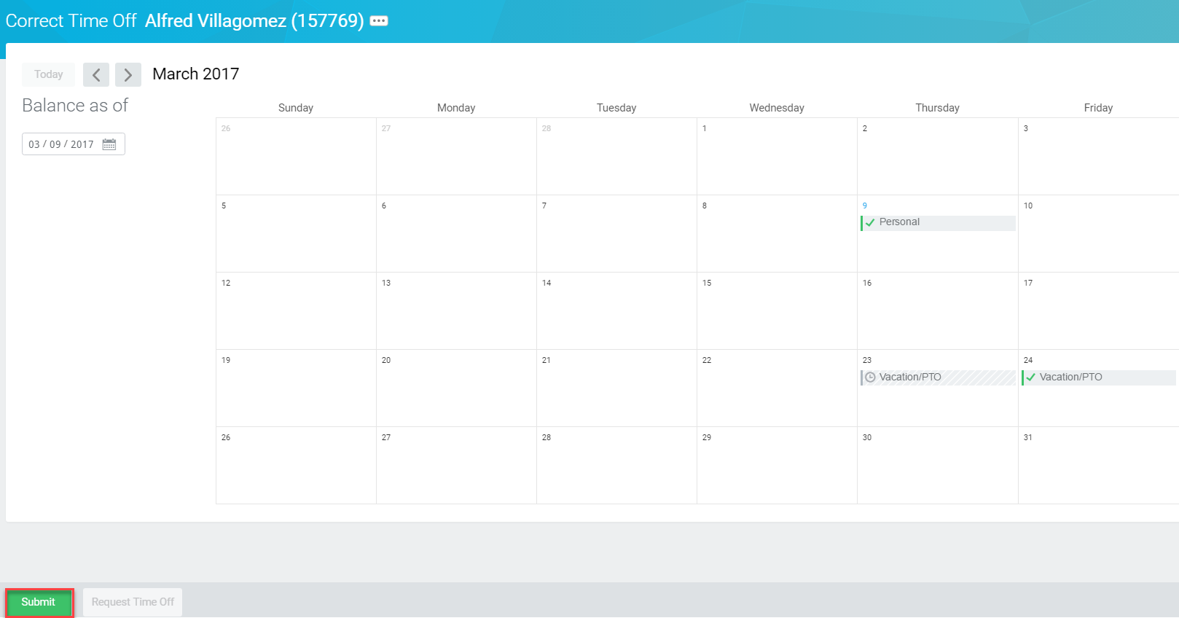

Click **Submit** from the Submit Time Off Correction view

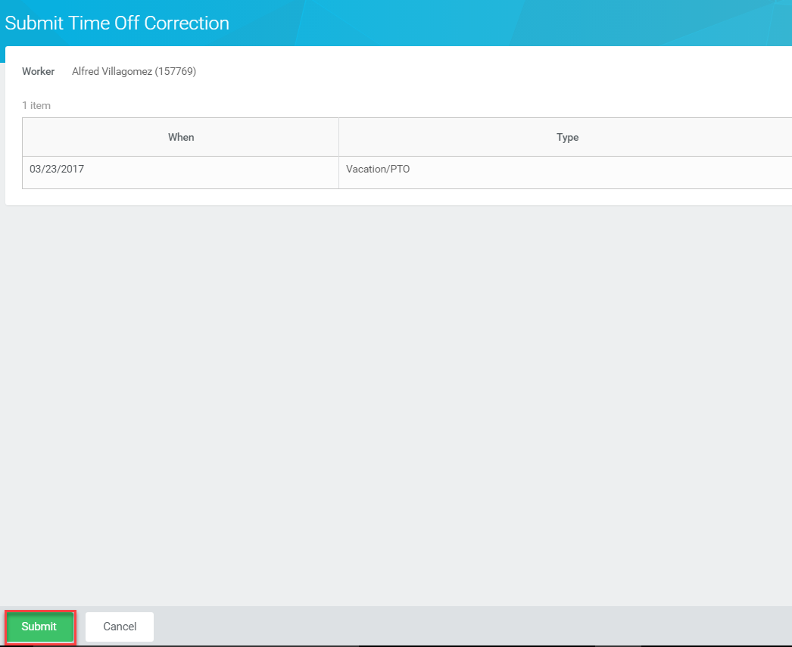

The time off correction is complete.

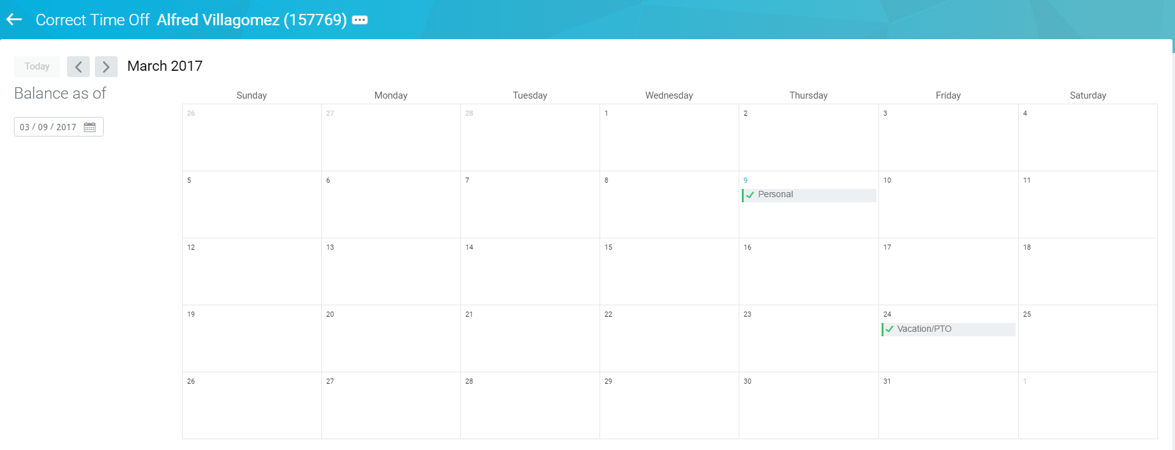

**Totals:**

As edits are completed, the changes are reflected in Totals in the upper right section of the screen. These are the totals that are sent to Payroll once the timesheet is submitted and approved.

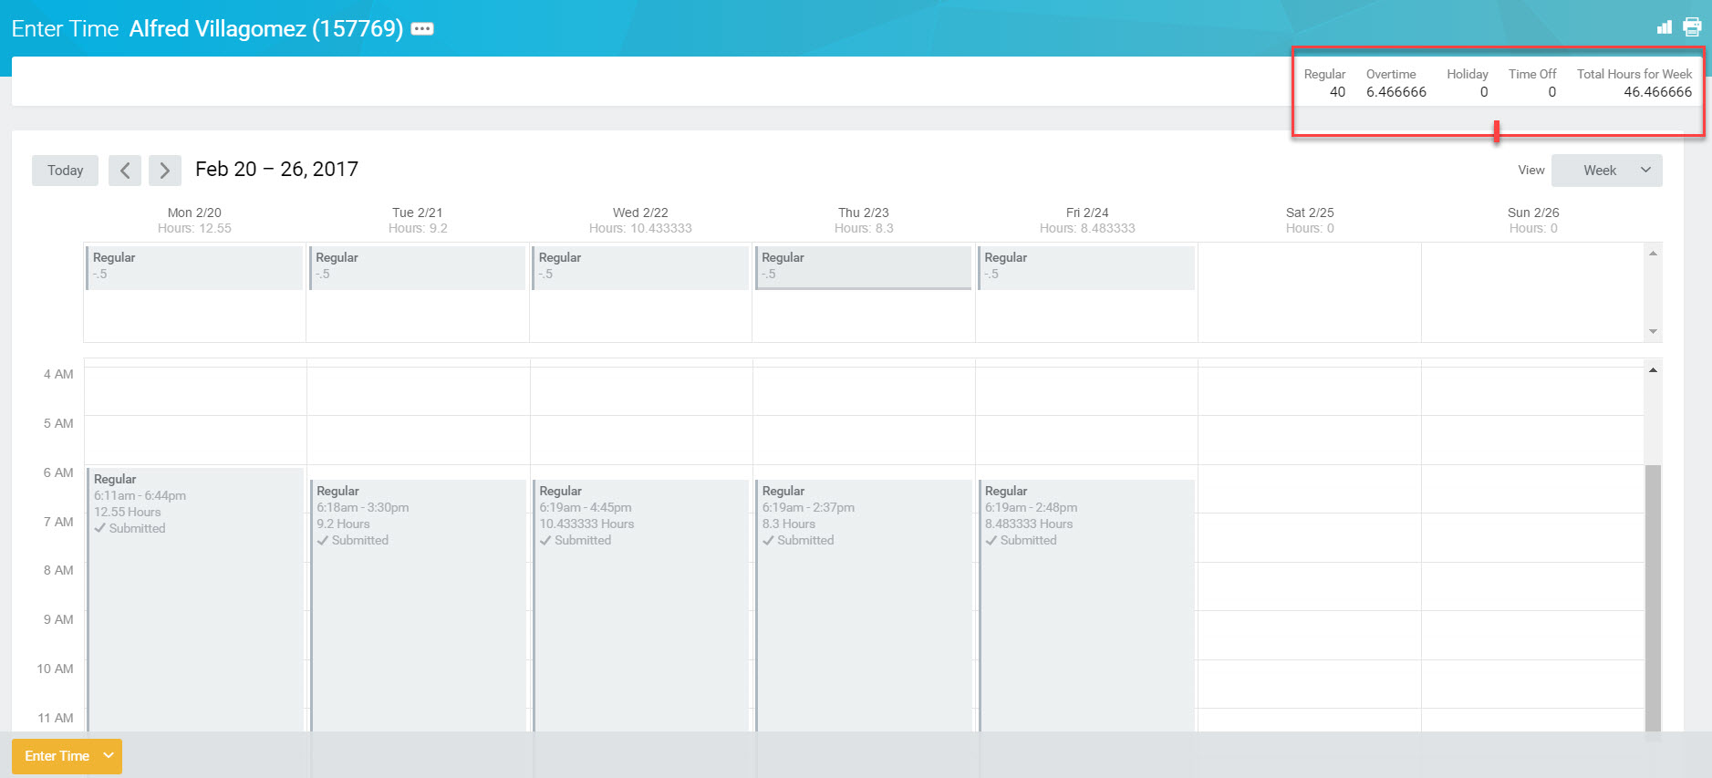

**Printing:** This view can also be printed by clicking the **printer** icon in the upper right section of the screen. This view is helpful when you have multiple time calculations for an employee and you want to verify to where it’s mapping.

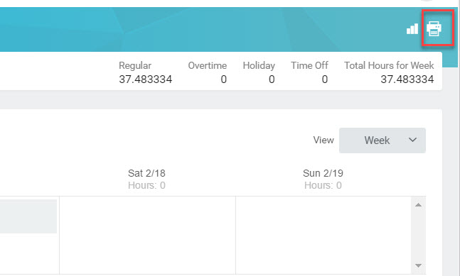

A Print Document notification will appear stating that the document can be found from a notification link via the **My Account** icon. Click **OK.**

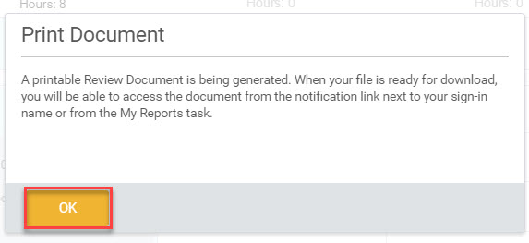

From the **My Account** icon, click **Notifications**

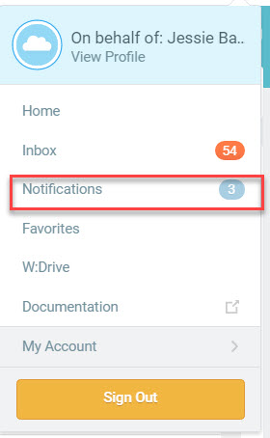

From the **Notifications** page, click the document hyperlink

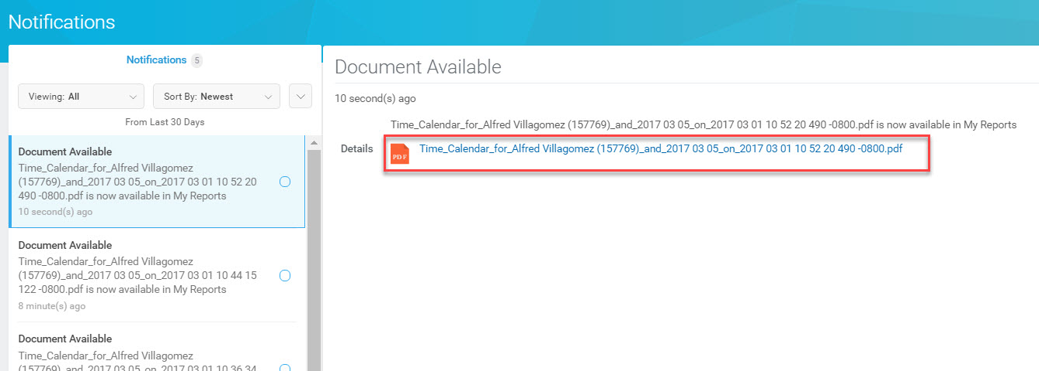

The document will quickly download and can be accessed by clicking the pdf, usually, found in the lower left corner of the screen.

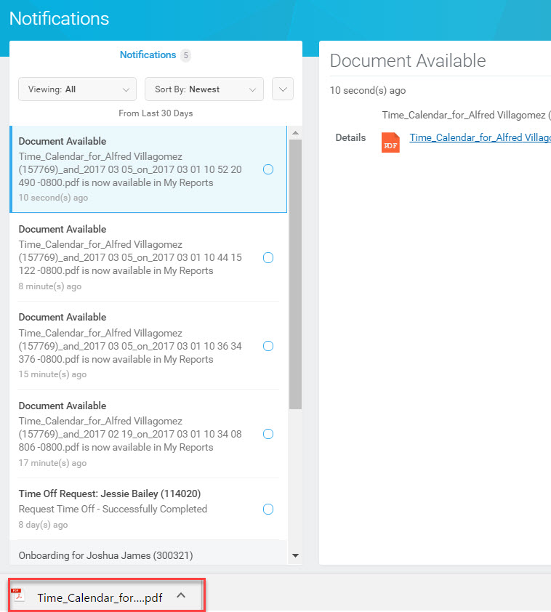

The document then opens as a pdf allowing you to click the **printer icon** and print. Again, this view is helpful when you have multiple time calculations for an employee and you want to verify to where it’s mapping.

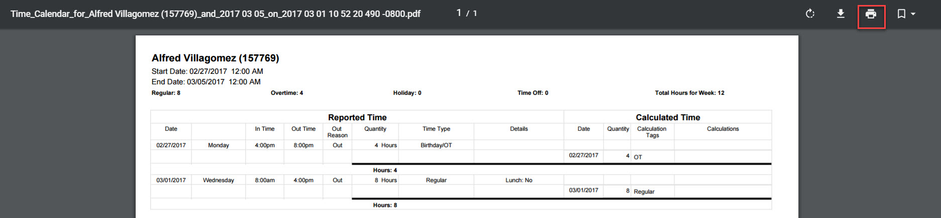

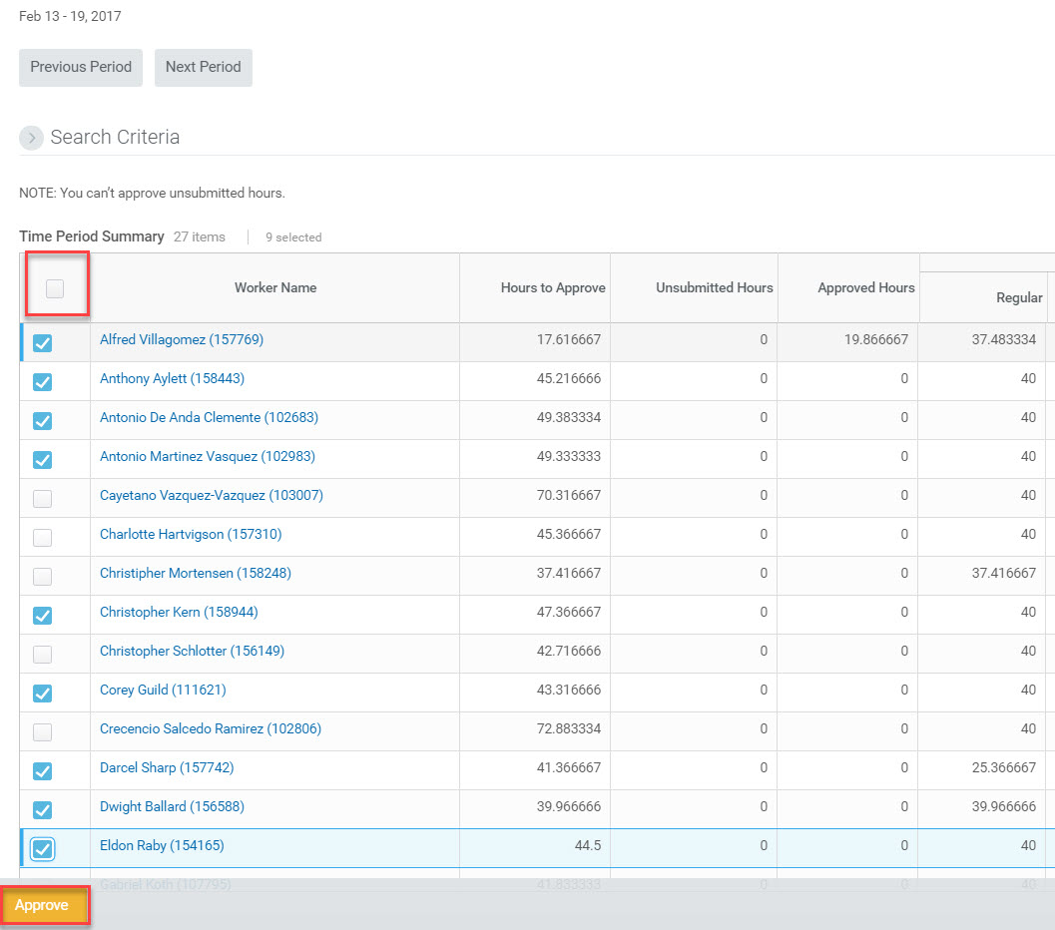**Step 5:** Once you have completed your editsgo back to the main review time report. Select everyone who has time that needs to be approved and click **Approve.**

You can also bulk approve from your inbox. Click on the drop-down to the right and select **Bulk Approve.**

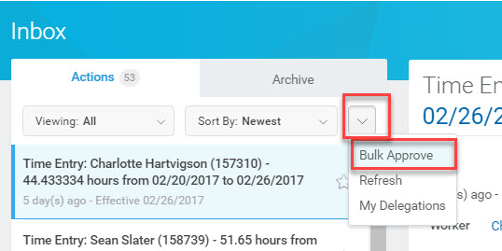Click the **Select All** checkbox to select all items on the screen for approval or individually check the items in the **Select** column you’d like to approve. Once done, click **OK.**

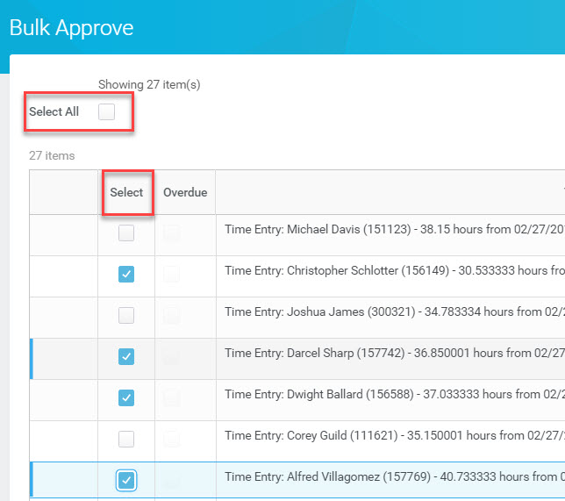

Below is an image of a fully approved timesheet

